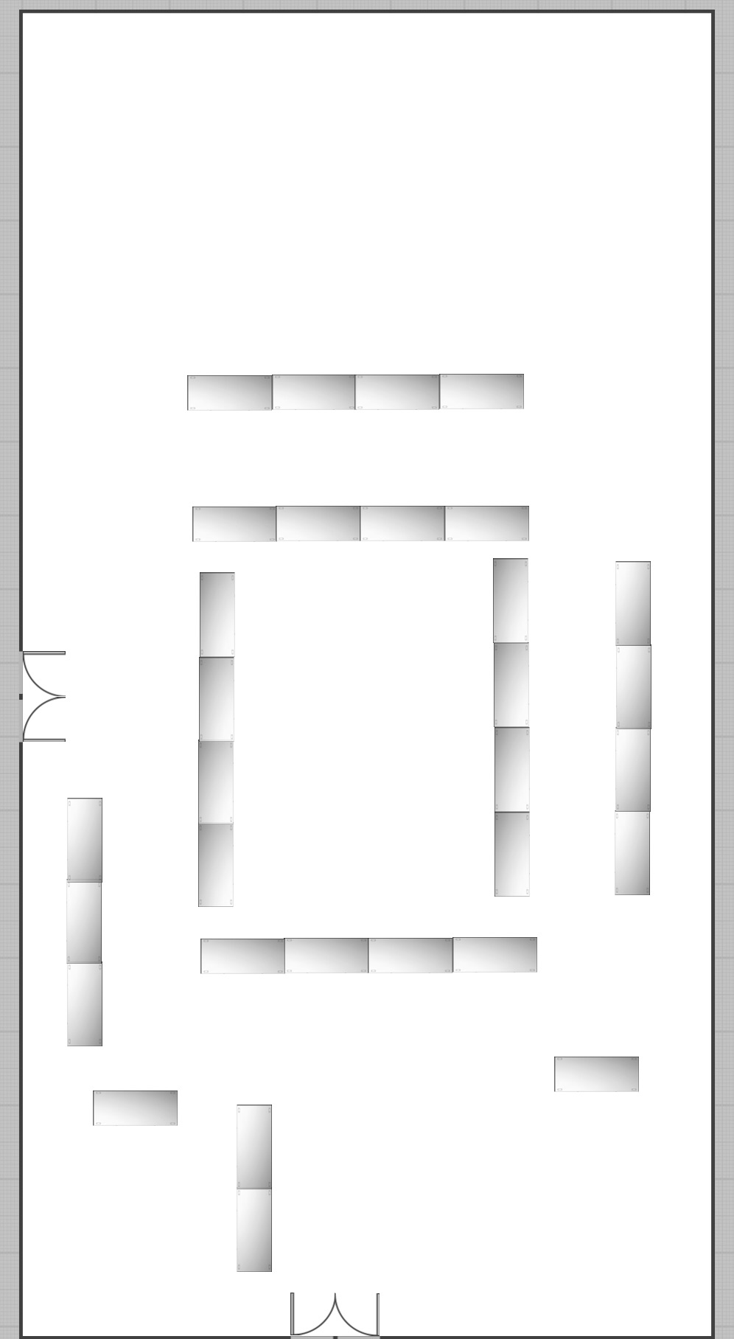
Sign-In
28
27
26
25
24
23
22
21
20
19
18
17
16
15
14
13
12
11
10
9
8
7
6
5
4
3
2
1
SABA

